AERO 368 Propulsion KNUST

MidTerm Exam April 9, 2019

Problem 1 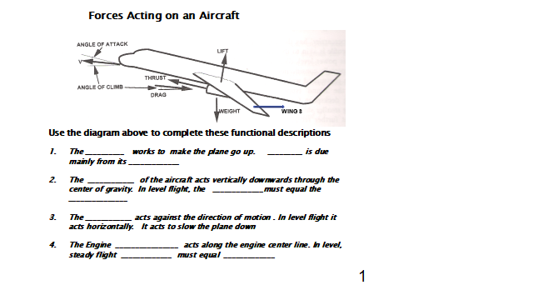Problem 2

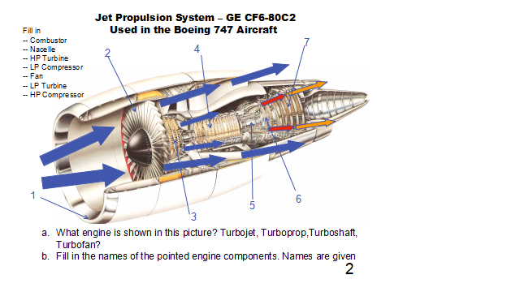

Problem 3

Consider a rocket being launched vertically into space from the surface of the earth. Assume a control volume attached to the rocket, and that the mass within the control volume remains constant. Which of the terms in the integral momentum equation are non-zero.

Σ Fz - aoΣρdv = ∂ ∫∫∫ρuzdv + ∫∫ uz(ρ**u.n**ds)

∂t

1 2 3 4

1. 1, 2, 3, 4
2. 1,2,4
3. 1,2
4. 1
5. None

Problem 4

For this problem evaluate the surface integral ∫∫ **u**(ρ**u.n**ds) for the flow in figure below. **Note**: it is a vector!

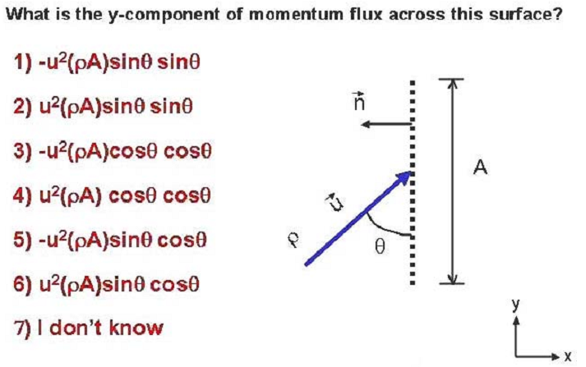

Problem 5

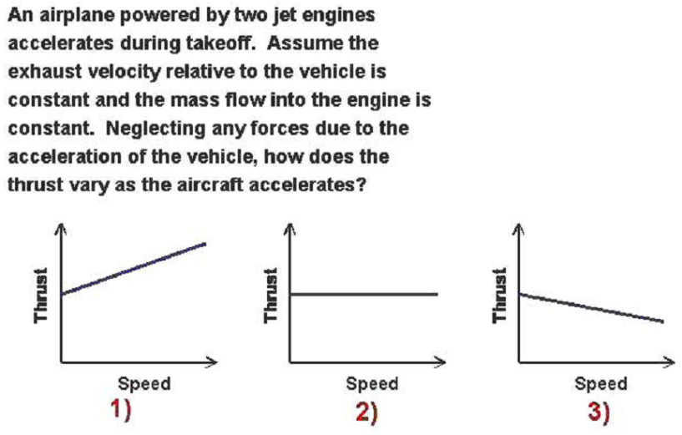

Lab Report: Title?????????

Consult class notes and lab manual.

For the five throttle settings calculate, based on ideal Brayton cycle, the following performance parameters,

(given: inlet conditions P2, T2, f=mf/mg (fuel/total flow ratio, and P3/P2 compression ratio)

1. P5
2. T5
3. T4
4. Thermal efficiency ηth
5. Work output W = ηth Qin
6. Exit velocity ue
7. Exit temperature Te
8. Static trust (momentum theorem), Fo
9. Specific fuel consumption SFC

10.Plot all results versus throttle settings (ie f).

11.(where possible)Compare with test results and comment on results.

Assume the following:

Cp for air = 1000 J/kgK

γ for air = 1.4

h = 4.3x107J/kg (if not given for fuel used)